ORIGINAL ARTICLE: JS Active/graphic data analysis 30-08-26 with ILR suggestions 06-09-26
Adrenal insufficiency occurs in a significant proportion of advanced HIV cases

TRP Mofokeng1, A Grossman2, RS Millar3, TS Pillay4, C Dandara5, R Erasmus6, G Johansson7, JB Sempa8, B Aslan9, G Nitschke9, J Singbo10, J Dave10, NS Levitt10, PJ Raubenheimer10, IL Ross10

1 Division of Endocrinology, Department of Medicine University of the Free State, South Africa
2 Centre for Endocrinology, Barts and the London School of Medicine and Dentistry, Queen Mary University of London, UK, and Green Templeton College, University of Oxford, UK
3 Department of Immunology, Faculty of Health Sciences, University of Pretoria, Private Bag X323, Pretoria 0031, South Africa
4 Department of Chemical Pathology and National health Laboratory Servi Tshwane Academic Division, Faculty of Health Sciences, University of Pretoria, South Africa
5 Division of Human Genetics, University of Cape Town
6 Tygerberg Hospital, National Health Laboratory Service, Faculty of Medicine, Stellenbosch University, Cape Town, South Africa
7 Department of Endocrinology, Sahlgrenska Academy, Sahlgrenska University Hospital and Institute of Medicine, University of Gothenburg, Gothenburg, Sweden
8 Department of Statistics, University of the Free State, South Africa
9 Department of Computer Science, University of Cape Town, South Africa
10 Division of Endocrinology, Department of Medicine, University of Cape Town, South Africa

Correspondence should be addressed to:
Prof Thabiso RP Mofokeng,
Division of Endocrinology,
Department of Medicine (University of the Free State) South Africa,
e-mail: mofokengtrp@ufs.ac.za

Abstract:
Background:
Sub-Saharan Africa is burdened by a vast HIV-positive population, at risk of life-threatening AIDS-defining illnesses, associated with primary (PAI) and secondary adrenal insufficiency (SAI). We hypothesised that adrenal insufficiency (AI) may partially account for the high mortality in advanced HIV.

Materials & Methods:
We undertook a prospective case-finding study of HIV-positive patients presenting with advanced disease, older than 18 years, a CD4 count of less than 100 cells/mm³, and a coexistent opportunistic infection. Exclusion criteria were the use of oral, intravenous, topical or inhaled steroids in the previous 3 months. AI diagnosed with a 30 minute stimulated serum cortisol < 400 nmol and 21 (3.73%), using a random serum cortisol <274 nmol/L.

Results:
Of 589 patients recruited, 563 had complete records. The median interquartile range (IQR) age of patients at enrolment was 36.0 years (IQR: 31.0-43.0). Patients in the lowest CD4 tertile and highest viral loads were younger and were more likely to have Candida albicans than in the remaining CD4 tertiles; p=0.003 and p<0.001, respectively. Of 563 patients, 14 (2.49%) had Cryptococcus neoformans which predominated in the AI-group (42.9% vs 4.3%), p=0.001.
The AI incidence was 6.57%, with the mortality of 19.35%. Cryptococcus predominated in the AI-group 60% vs 5.7% (p=0.028). Regression analysis revealed that a 50 nmol/L cortisol increase was associated with a 14% increase in the odds of death (OR = 1.14, (95%CI: 1.08, 1.21); p<0.001), whereas 100 pg/L increase in plasma ACTH was associated with a 117% increase in the odds of death (OR = 2.17, (95%CI: 1.35, 3.72) (p<0.003).

Conclusion: No results here, please!
The largest African study to date of hypoadrenalism in advanced HIV revealed AI with considerable mortality. Cryptococcus neoformans clustered among patients with AI who died compared with patients who survived and did not have AI and was associated with a higher mortality.
I suggest we test every AIDS & Crypto + patient for AI? TRPM (04-09-26)

300 Words:

HAART – Highly Active Anti-Retroviral Therapy, PTB – pulmonary tuberculosis, EPTB – Extrapulmonary tuberculosis

Introduction
Adrenal insufficiency (AI) is invariably fatal without appropriate replacement. Prior to glucocorticoids, most patients with primary adrenal insufficiency (PAI) died within 2 years of diagnosis [1]. Autoimmune AI predominates both in European populations [2] and also in South Africa [3], despite the high background prevalence of tuberculosis (TB) [4]. However, our recent African survey suggests that PAI is attributable to TB and Acquired Immune Deficiency Syndrome (AIDS) in 34% and 29.8%, respectively [5].
The background prevalence of Human Immunodeficiency Virus (HIV) in sub-Saharan Africa is 9% [6, 7], with lower mortality in better resourced settings, [8] due to earlier presentation and adequate funding, compared with limited resourced health systems. Patients with HIV may develop PAI due to inter alia TB, Mycobacterium avium intracellulare (MAI), cytomegalovirus (CMV), toxoplasmosis, Pneumocystis carinii, histoplasmosis, and malignancies for example, non-Hodgkin’s lymphoma and Kaposi sarcoma (KS). Fungal infections including cryptococcus, blastomycosis, and histoplasmosis, and various medications including ketoconazole and mitotane, may cause PAI [9]. Secondary adrenal insufficiency (SAI) in HIV may be due to inter alia TB, toxoplasmosis and CMV [10] [11, 12].
The reported incidence of hypoadrenalism in patients with HIV varies. In a study in Pakistan by Afreen et al, of 64 HIV infected patients, predominantly male (84.9%), the AI incidence was 9 (14.0%), using the 250 µg intravenous tetracosactide test and a 60 minute serum cortisol concentration of less than 18 µg/dL (500 nmol/L) [13], whereas in a Nigerian study of 43 newly-diagnosed HIV-positive patients, and antiretroviral treatment naïve, AI occurred in 34.8%, using the 1 µgtetracosactide test [14] and a 30 minute serum cortisol of less than 500 nmol/L. In India, Sharma et al, reported AI in 24.23%, using a cortisol cutoff of less than 500 nmol/L, following the 250 µg tetracosactide test [15].
Despite optimal replacement therapy, patients with AI per se demonstrate poorer survival due to cardiovascular, malignant and infectious diseases, compared with background populations [10, 16]. Both over- and under-treatment with glucocorticoids during infections and stress-related events confer increased mortality [17].

A 2023 UN report identified 260 000 AIDS-related Sub-Saharan deaths in 2022 [18]. As AIDS can predispose to AI, we hypothesised that coexistent AI among patients with advanced HIV, may accelerate mortality. Our objectives were to determine the incidence of AI among ill, hospitalised HIV-infected patients. We also wished to explore the positive predictive clinical and biochemical characteristics of AI, and predictors for survival. Moreover, we wished to evaluate whether artificial intelligence could correctly diagnose AI and its utility in diagnosing AI with advanced HIV.

Materials and Methods
This was a prospective case-finding study of advanced HIV-positive patients, presenting with an opportunistic infection (OI) to an acute tertiary care medical ward. All participants provided written informed consent. If participants were affected by delirium, our Research and Ethics committee endorsed retrospective informed consent, to limit bias and an equal opportunity for life-saving treatment. Approval to conduct the study (HREC 163/2015) was obtained from the University of Cape Town Faculty of Health Sciences, Human Research and Ethics Committee, endorsing the 2013 declaration of Helsinki.

Inclusion and exclusion criteria
Inclusion criteria included age 18 years and older, a CD4 count of 100 cells/mm³ or fewer and an intercurrent OI. The use of oral, topical or inhaled steroids in the previous 3 months was an exclusion criterion.

Data extraction
Samples were taken for random serum cortisol and plasma ACTH between 08:00 and 09:00 on the day of enrolment and were analysed at a private accredited laboratory. Demographic and clinical data were obtained. Routine biochemistry, haematology and microbiology were extracted from the National Health Laboratory Service (NHLS) repository. If the serum cortisol was <500 nmol/L, a short 250 µg intravenous tetracosactide (synthetic ACTH) stimulation test was performed, usually on the subsequent day after admission. For those who did not undergo the stimulation test, a random cortisol <140 nmol/L was assumed to indicate AI, those with a serum cortisol between 141 nmol/L and 274 nmol/L were considered ‘likely’ to have AI and those with cortisol >274 nmol/L were considered unlikely to have AI [19]. For those participants who underwent a tetracosactide test a stimulated serum cortisol less than 400 nmol/L was considered compatible with hypoadrenalism.
Biochemical measures of plasma ACTH and serum cortisol
We utilised the Roche COBAS electrochemiluminescence immunoassay (ECLIA) tests to measure both serum cortisol and plasma ACTH.

Methodology for serum Cortisol and ACTH
Serum cortisol concentrations were assayed on the Roche Cobas 6000 e601 platform, using the Elecsys Cortisol II antibody, determined by ECLIA. This method was standardized against the institute for reference materials and measurements (IRMM)/IFCC-45 panel. The assay range for serum cortisol was from 1.5 nmol/L to 1750 nmol/L, with a limit of detection (LOD) of 1.5 nmol/L [20].

The tetracosactide test
Plasma ACTH and serum cortisol were collected immediately prior to administering 250 µg of synthetic ACTH intravenously at 0 minutes and were submitted to the National Health Laboratory Services (NHLS). A 30-minute stimulated serum cortisol was taken at the conclusion of the test. In patients with confirmed cortisol deficiency, a concomitant plasma ACTH above the upper limit of the reference range (67.7 pg/mL) was consistent with PAI [21], while a low or normal plasma ACTH was diagnostic of SAI [20].

Incremental cortisol
This measured a change in serum cortisol, in response to intravenous ACTH stimulation and calculated as follows:
Delta cortisol (%) = (Stimulated cortisol - Basal cortisol) / Basal cortisol × 100.
Determination of survival
Telephonic follow-up enabled survival determination from hospital after discharge, through direct or family contact. Clinicom® also corroborated survival, by their most recent attendance at various clinics.
Statistical analysis:
Statistical analyses were performed using R-programing software (ref: R Core Team (2023). R: A Language and Environment for Statistical Computing_. R Foundation for Statistical Computing, Vienna, Austria. https://www.R-project.org/).
Categorical variables were presented as frequencies and percentages, and continuous variables were expressed as medians and were compared, using the Wilcoxon-Mann-Whitney test. Proportions and categorical variables were compared, using Pearson’s chi-squared test or Fisher’s exact test as appropriate. We ranked CD4 counts (cells/mm³) into tertiles of 0-33; 34-66 and 67-100, respectively to determine if AI was associated.
The Kaplan-Meier curve compared overall survival, defined as the time to death, survival at 3, 6 and 12 months between the AI and non-AI groups. Bivariate analysis using logistic regression to examine a correlation between each independent variable and mortality was undertaken. For missing data, we utilised the mice package in R for multiple imputations, enabling a complete dataset. Collinearity among the independent variables was looked for, to ensure regression estimates were reliable.
Various feature selection methods were used to pinpoint relevant variables to be included in our multivariate regression model. The final model enabled us to identify factors independently associated with mortality. We considered significance if the p-value <0.05. Our findings were presented as adjusted Odds Ratios (aORs), 95% confidence intervals (95% CI) and corresponding p-values.

Recruited (N=589): HIV-positive adults with CD4 count <100 cells/mm³ and at least one opportunistic infection.
Excluded (N=26):
No consent & Incomplete data
Topical steroids use
Enrolled (N=563)
Excluded Adrenal Insufficiency (Non-AI) (N=528)

Confirmed Adrenal Insufficiency (AI) (N=35)
AI by stimulated Cortisol
14 using < 400 nmol/L,

21 AI by Random Cortisol < 274 nmol/L

Figure 1: Consort flow diagram of patient enrollment

Results:
Of 589 patients, 563 participants were included due to 26 with incomplete data. (Figure 1). Most patients were female 282 (50.7%) and median age (IQR) at enrollment was 36 years (31.0-43.0) years; when subdivided by CD4 counts, participants were younger in the lowest CD4 tertile, 35 years (30.0-42.0; p=0.021), compared to the remaining tertiles. The predominant OI was TB in 459 (84.5%), bacterial pneumonia 62 (11.4%), candida 35 (6.4%) and cryptococcus infection in 29 (5.3%) (Table 1).
Gender, ethnicity and duration of illness did not differ by CD4 tertiles. As expected, the participants with the lowest CD4 counts had the highest HIV viral load (p=0.001). White cell, lymphocyte and neutrophil counts were lower in the lowest CD4 tertile (p<0.001, p=0.021 and p=0.021), respectively, compared with the remaining tertiles. Proportions with TB, pneumonia, candida and cryptococcus did not differ across the CD4 tertiles.
HAART vs HAART naïve
The subgroup of patients receiving highly-active antiretroviral therapy (HAART) (408), compared with the HAART-naïve (155) group, 6 (2.6%) had cryptococcal infection, compared with 24 (7%) who did not (p=0.039). CD4 counts, and viral loads did not differ between patients on HAART versus those who were HAART-naïve.

Table 1: Patient presentation by CD4 count in tertiles with the p-values comparing patient clinical characteristics on admission across the tertiles
Variable | Overall,  N = 558¹ | 0 - 33,  N = 278¹ | 34 - 66,  N = 156¹ | 67 - 100,  N = 124¹ | p-value²
Age at enrolment, median (IQR) (years) | 36.0 (31.0, 43.0) | 35.0 (30.0, 42.0) | 37.0 (32.0, 44.0) | 38.0 (33.0, 46.0) | 0.003
Gender, N (%) |  |  |  |  | 0.2
Female | 282 (50.6%) | 139 (50.0%) | 87 (55.8%) | 56 (45.5%)
Duration of current illness, median (IQR) (days) | 14.0 (12.0, 21.0) | 14.0 (14.0, 21.0) | 14.0 (11.5, 21.0) | 14.0 (7.0, 21.0) | 0.067
Weight loss | 465 (86.4%) | 236 (87.1%) | 133 (87.5%) | 96 (83.5%) | 0.6
HIV log10 viral load | 10.7 (7.3, 12.4) | 11.6 (9.3, 12.8) | 8.9 (6.3, 12.3) | 7.6 (3.9, 10.3) | <0.001
Opportunistic infections
Tuberculosis | 459 (84.4%) | 229 (84.5%) | 131 (86.2%) | 99 (81.8%) | 0.6
Pneumonia | 62 (11.4%) | 30 (11.1%) | 19 (12.5%) | 13 (10.7%) | 0.9
Candida albicans | 35 (6.4%) | 22 (8.1%) | 11 (7.2%) | 2 (1.7%) | 0.049
Cryptococcus neoformans | 29 (5.3%) | 15 (5.5%) | 5 (3.3%) | 9 (7.4%) | 0.3
Gastroenteritis | 23 (4.2%) | 12 (4.4%) | 7 (4.6%) | 4 (3.3%) | 0.8
Hepatitis B | 18 (3.3%) | 9 (3.3%) | 8 (5.3%) | 1 (0.8%) | 0.12
Syphilis | 17 (3.1%) | 8 (3.0%) | 8 (5.3%) | 1 (0.8%) | 0.11
Kaposis sarcoma | 6 (1.1%) | 6 (2.2%) | 0 (0.0%) | 0 (0.0%) | 0.056
Urinary tract infection | 7 (1.3%) | 4 (1.5%) | 0 (0.0%) | 3 (2.5%) | 0.2
Pneumocystis Jiroveci Pneumonia | 5 (0.9%) | 4 (1.5%) | 1 (0.7%) | 0 (0.0%) | 0.5
Herpes simplex virus | 8 (1.5%) | 3 (1.1%) | 4 (2.6%) | 1 (0.8%) | 0.4
Bacterial meningitis | 6 (1.1%) | 3 (1.1%) | 1 (0.7%) | 2 (1.7%) | 0.8
Haematological parameters
White cell count x10⁹/L | 5.4 (3.7, 8.2) | 5.1 (3.0, 7.4) | 5.7 (4.2, 8.6) | 6.9 (4.5, 9.9) | <0.001
Lymphocyte count x10⁹/L | 0.8 (0.4, 1.8) | 0.6 (0.3, 1.3) | 0.9 (0.5, 4.9) | 1.3 (0.8, 2.9) | 0.004
Neutrophils x10⁹/L | 3.4 (1.5, 8.5) | 2.4 (1.1, 6.2) | 6.6 (1.9, 15.2) | 5.2 (3.1, 11.3) | 0.003
Medical history
HAART exposure | 204 (36.6%) | 100 (36.0%) | 61 (39.1%) | 43 (34.7%) | 0.7
Anti-tuberculous therapy | 13 (2.3%) | 5 (1.8%) | 3 (1.9%) | 5 (4.0%) | 0.4
Antifungal therapy | 6 (1.1%) | 2 (0.7%) | 1 (0.6%) | 3 (2.4%) | 0.3
¹Median (IQR); ²Wilcoxon rank sum test; Pearson's Chi-squared test; Fisher's exact test IQR-interquartile range, TB-tuberculosis, HAART Highly active antiretroviral therapy
^{p} -value is a simultaneous comparison of all the clinical characteristics by CD4 count tertiles.

Diagnosis of adrenal insufficiency
Fourteen AI patients were identified following a failed tetracosactide test, of whom 11 had SAI and 3 PAI, respectively. An additional 21 patients were diagnosed with AI when the random serum cortisol was less than 274 nmol/L, and of these, 19 had SAI and 2 were diagnosed with PAI. Overall, 35 had AI, 5 with PAI and 30 had SAI.
A random morning serum cortisol was lower in the AI versus the non-AI groups, 332 nmol/L (252.0-382.0) compared with 478 nmol/L (372.5-578.0), respectively ; (p<0.001). The median basal cortisol at 0 minutes was 300 nmol/L (188.5-359) in the AI group, compared with 466 nmol/L (352-573) without AI; (p<0.001). The stimulated cortisol was 379 nmol/L (314.5-440.0) in the AI group, compared with 722 nmol/L (630.0-858.0; p<0.001) without AI.
Clinical characteristics in patients with adrenal insufficiency with those without:
Cryptococcal infections occurred more often in the AI versus the non-AI groups (42.9% vs 4.3%); p=0.001(Table 2).

Table 2: Comparison of clinical characteristics in patients with adrenal insufficiency with those without
Variable | Non-AI, N = 549¹ | AI, N = 14¹ | p- value²
Age at enrolment, median (IQR) (years) | 36.0 (31.0, 43.0) | 44.5 (33.0, 50.0) | 0.3
Female gender, N (%) | 275 (50.2%) | 9 (64.3%) | 0.8
Duration of current illness, median (IQR) (days) | 14.0 (11.5, 21.0) | 14.0 (7.0, 30.0) | 0.9
HISTORY
Weight loss | 454 (86%) | 11 (79%) | 0.9
Weakness | 447 (85%) | 11 (79%) | 0.9
Tiredness | 450 (86%) | 11 (79%) | 0.9
Poor appetite | 398 (76%) | 12 (86%) | 0.9
Increased pigmentation of the skin | 261 (51%) | 3 (25%) | 0.5
Nausea | 282 (54%) | 7 (50%) | >0.9
Vomiting | 146 (28%) | 5 (36%) | 0.9
Liking for salt | 274 (52%) | 10 (71%) | 0.7
Hypoglycaemia | 11 (2.1%) | 0 (0%) | >0.9
Loss of consciousness | 7 (1.3%) | 0 (0%) | >0.9
Diarrhoea | 232 (45%) | 5 (36%) | 0.9
Dizziness | 255 (49%) | 5 (38%) | 0.9
Shock | 5 (1.0%) | 0 (0%) | >0.9
Anorexia | 251 (48%) | 2 (14%) | 0.2
Loss of axillary and pubic hair, if female | 101 (38%) | 1 (10%) | 0.5
CLINICAL FEATURES
BP (diastolic) mmHg | 70.0 (60.0, 79.0) | 71.5 (60.0, 80.0) | 0.9
Heart rate beats per minute | 90.5 (78.0, 109.0) | 85.0 (77.0, 93.0) | 0.8
Hypotension | 49 (9.4%) | 0 (0.0%) | >0.9
Any postural drop in blood pressure | 23 (4.4%) | 0 (0.0%) | >0.9
Presence of anaemia | 314 (60.4%) | 6 (42.9%) | 0.7
INVESTIGATIONS
Viral load (log10 copies/mL) | 4.7 (3.2, 5.4) | 5.3 (5.3, 5.3) | 0.9
Pulmonary tuberculosis | 341 (63.7%) | 7 (50.0%) | 0.8
Extra pulmonary tuberculosis | 107 (20.0%) | 3 (21.4%) | >0.9
Cryptococcus neoformans | 23 (4.3%) | 6 (42.9%) | 0.001
Pneumonia | 60 (11.2%) | 2 (14.3%) | >0.9
Hepatitis B | 16 (3.0%) | 2 (14.3%) | 0.5
Candida albicans | 34 (6.4%) | 1 (7.1%) | >0.9
Kaposis sarcoma | 6 (1.1%) | 0 (0.0%) | >0.9
Pneumocystis Jiroveci Pneumonia | 5 (0.9%) | 0 (0.0%) | >0.9
Herpes simplex virus | 8 (1.5%) | 0 (0.0%) | >0.9
Gastroenteritis | 23 (4.3%) | 0 (0.0%) | >0.9
Total CD4 count | 34.0 (14.0, 63.0) | 36.5 (15.0, 51.0) | >0.9
White cell count x10⁹/L | 5.6 (3.7, 8.2) | 4.1 (3.3, 6.5) | 0.9
Lymphocyte count x10⁹/L | 0.8 (0.4, 2.0) | 0.4 (0.4, 0.5) | 0.8
Neutrophils x10⁹/L | 3.6 (1.5, 8.9) | 1.3 (1.0, 1.7) | 0.7
Sodium mmol/L | 133.0 (130.0, 137.0) | 136.0 (133.0, 139.0) | 0.6
Potassium mmol/L | 4.1 (3.6, 4.6) | 3.5 (3.3, 4.0) | 0.2
Haemoglobin g/dL | 8.7 (7.4, 10.3) | 8.7 (7.9, 10.3) | >0.9
MANAGEMENT & OUTCOMES
Mortality | 162 (68%) | 5 (71%) | >0.9
Fluconazole | 69 (13%) | 5 (36%) | 0.3
Opiates | 121 (22%) | 5 (36%) | 0.9
HAART exposure | 199 (36%) | 5 (36%) | >0.9
¹Median (IQR); N (%); ²Wilcoxon rank sum test; Pearson’s Chi-squared test; Wilcoxon rank sum exact test; Fisher’s exact test

Add a paragraph highlighting the differences between the 14 & 21 & 35 vs The Non-AI group: ILR
AI incidence | 14/163 via Stimulation test |  | 21 by random cortisol 274 nmol/L |  | 35 in Total
 | SAI = 11 | PAI = 3 | SAI = 20 | PAI = 3 | SAI = 31 | PAI = 6
Treated | 3 (27%) | 3 (100%) | 2 (10%) | 1 (33%) | 10 (32%) | 4 (67%)
Untreated | 8 (73%) | 0 | 18 (90%) | 2 (67%) | 21 (68%) | 2 (33%)
Mortality - 5 | 3 (100%) | 2 (100%) | 1 (100%) | 0 | 4 (100%) | 2 (100%)
? Survival benefit for the treated vs non-Treated
5/14 SYNACTHEN AI mortality
Zero/21 (274 AI) mortality
Few numbers problem makes it difficult to show effect.
Comparison between PAI and SAI
There were no differences in the profile of random, basal, stimulated and incremental serum cortisol among patients with SAI, compared with patients with PAI (Fig 2). Apart from ACTH concentrations; p<0.001 there were no differences in demographic data, history, clinical findings, investigations and mortality in SAI, compared with PAI.
Table 3: Comparisons of the clinical characteristics of patients who died with AI versus those who survived without AI
Except for Cryptococcus neoformans which predominated in the AI group 60% to 3.7%., p=0.009 and was highly associated with mortality. There were no differences in the clinical characteristics between the group with AI and one which survived without AI. As expected, the group with AI who died had much lower concentrations of random cortisol, absolute delta cortisol and percentage change in cortisol 251 vs 444., p=0.017, 316 vs 698., p=0.008, and 10.2 vs 68.1., p=0.026, respectively.

Table 3: Comparisons of the clinical characteristics of patients who died with AI versus those who survived without AI
Variable | AI, N = 5¹ | Non-AI, N = 387¹ | p-value²
Age at enrolment, median (IQR)  (years) | 47.0 (42.0, 48.0) | 36.0 (31.0, 43.0) | 0.5
Female gender, N(%) | 4 (80.0%) | 190 (49.2%) | 0.8
Duration of current illness, median  (IQR) (days) | 10.5 (7.0, 37.0) | 14.0 (10.0, 21.0) | >0.9
HISTORY
Weight loss | 4 (80%) | 320 (85%) | >0.9
Weakness | 5 (100%) | 316 (85%) | >0.9
Tiredness | 5 (100%) | 316 (84%) | >0.9
Poor appetite | 5 (100%) | 273 (74%) | 0.9
Increased pigmentation of the skin | 1 (25%) | 175 (48%) | >0.9
Nausea | 3 (60%) | 192 (51%) | >0.9
Loss of consciousness | 0 (0%) | 3 (0.8%) | >0.9
Diarrhea | 1 (20%) | 159 (43%) | 0.9
Dizziness | 1 (20%) | 178 (48%) | 0.9
Shock | 0 (0%) | 3 (0.8%) | >0.9
Anorexia | 1 (20%) | 175 (47%) | 0.9
Loss of axillary and pubic hair, if  female | 1 (25%) | 65 (35%) | >0.9
CLINICAL FEATURES
BP (systolic) mmHg | 120.0 (120.0, 130.0) | 112.0 (104.0, 126.0) | 0.9
BP (diastolic) mmHg | 63.0 (60.0, 80.0) | 70.0 (60.0, 76.0) | >0.9
Heart rate beats per minute | 82.0 (65.0, 92.0) | 90.0 (79.0, 110.0) | 0.9
Hypotension | 0 (0.0%) | 33 (8.9%) | >0.9
Any postural drop in blood pressure | 0 (0.0%) | 16 (4.3%) | >0.9
Presence of anaemia | 2 (40.0%) | 217 (58.6%) | >0.9
INVESTIGATIONS
Sodium mmol/L | 139.0 (133.0, 139.0) | 134.0 (130.0, 137.0) | 0.7
Potassium mmol/L | 3.8 (3.7, 4.0) | 4.1 (3.7, 4.6) | 0.6
Haemoglobin g/dL | 8.7 (8.1, 10.2) | 8.9 (7.5, 10.6) | >0.9
Syphilis | 0 (0.0%) | 14 (3.7%) | >0.9
Candida | 0 (0.0%) | 26 (6.9%) | >0.9
Hepatitis B | 1 (20.0%) | 11 (2.9%) | 0.6
Herpes simplex virus HSV | 0 (0.0%) | 6 (1.6%) | >0.9
Pneumonia | 0 (0.0%) | 46 (12.2%) | >0.9
Pneumocystis Jiroveci Pneumonia | 0 (0.0%) | 3 (0.8%) | >0.9
Pulmonary tuberculosis | 2 (40.0%) | 237 (62.9%) | 0.9
Extrapulmonary tuberculosis | 1 (20.0%) | 76 (20.2%) | >0.9
Cryptococcus neoformans | 3 (60.0%) | 14 (3.7%) | 0.009
Total CD4 count cells/ mm3 | 17.0 (15.0, 43.0) | 35.0 (15.0, 65.0) | >0.9
Viral load (log10 copies/mL) | NA (NA, NA) | 10.3 (6.3, 12.2)
Random cortisol nmol/L | 251.0 (237.0, 281.0) | 444.0 (349.0, 553.0) | 0.017
Basal cortisol nmol/L | 266.0 (228.0, 301.0) | 412.0 (302.0, 559.0) | 0.063
Stimulated cortisol nmol/L | 316.0 (296.0, 335.0) | 698.0 (576.5, 811.0) | 0.008
Absolute delta cortisol | 30.0 (17.0, 32.0) | 276.0 (178.0, 380.0) | 0.008
Percentage change in cortisol levels* | 10.2 (9.9, 11.3) | 68.1 (34.4, 119.8) | 0.026
¹Median (IQR); N (%); ²Wilcoxon rank sum test; Pearson’s Chi-squared test; Wilcoxon rank sum exact test; Fisher’s exact test
*Difference in the basal, compared to the stimulated cortisol, expressed as a percentage basal cortisol p-value is a comparison of clinical characteristics of patients with AI versus those without AI, among all those who had died

Table 3a: Deep dive on Addison’s disease patients

Comparisons of clinical characteristics: Patients who died with AI vs. Patients alive without AI

Cryptococcal neoformans predominated in patients with AI who died than in the group of survivors, 50.0% vs 3.9%; p<0.016. Low random, stimulated, absolute delta cortisol, and percentage change in cortisol levels predominated in the in patients with with AI who died compared to the survivors.

Table 2: Comparisons of clinical characteristics: Patients who died with AI vs. Patients alive without AI
Variable | Died with AI N = 6¹ | Alive without AI N = 365¹ | Adj. p-value²
Cryptococcus neoformans | 3 (50.0%) | 14 (3.9%) | 0.016
Random cortisol nmol/L | 244.0 (235.0, 281.0) | 455.0 (365.0, 555.0) | 0.005
Basal cortisol nmol/L | 266.0 (228.0, 301.0) | 412.0 (302.0, 559.0) | 0.067
Stimulated cortisol nmol/L | 316.0 (296.0, 335.0) | 698.0 (576.5, 811.0) | 0.005
Absolute delta cortisol | 30.0 (17.0, 32.0) | 276.0 (178.0, 380.0) | 0.006
Percentage change in cortisol levels* | 10.2 (9.9, 11.3) | 68.1 (34.4, 119.8) | 0.027
¹Median (Q1, Q3); n (%)
²Wilcoxon rank sum test; Fisher's exact test

Crypto is VIP
Highly associated with mortality:
Put it in the results section, Abstract, Discussion and Conclusion. ILR
Treatment and outcomes

Mortality in the subgroup of patients with AI versus without AI
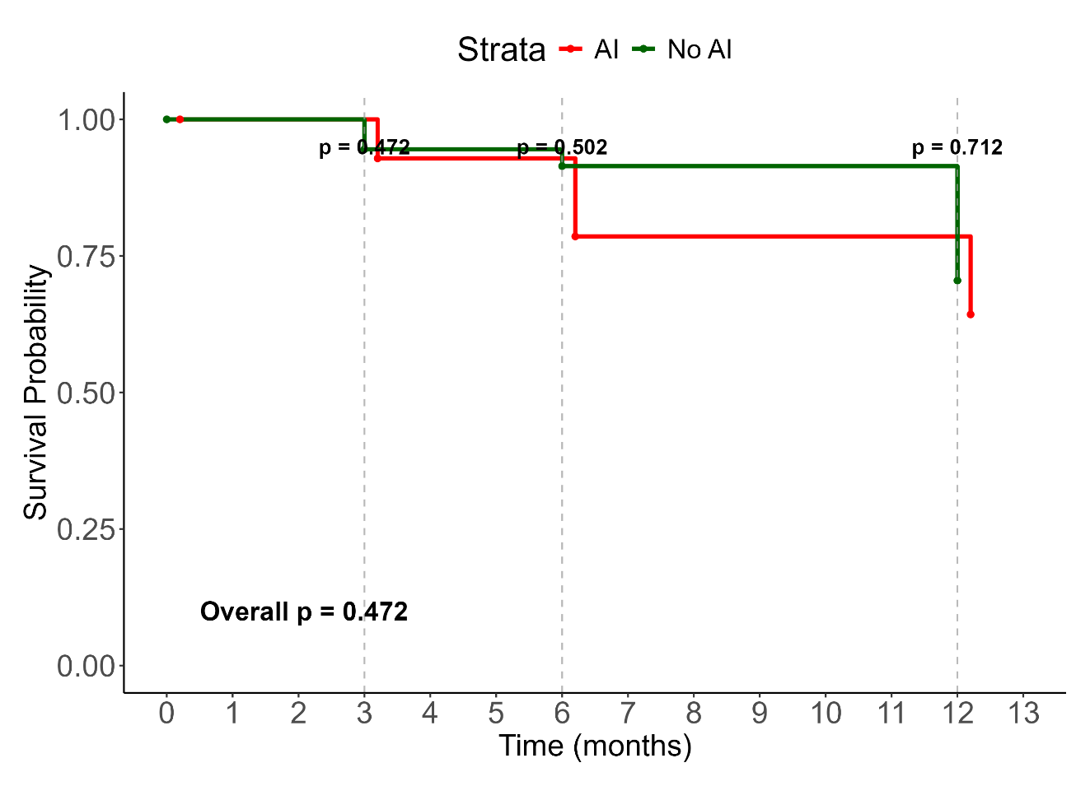
Figure 2: The Kaplan-Meier survival curves for patients with adrenal insufficiency (AI) compared with those without (No-AI) in HIV-positive patients with a CD4 count less than 100 cells per mm³ N=14
p-values at 3-months, 6-months, 12-months

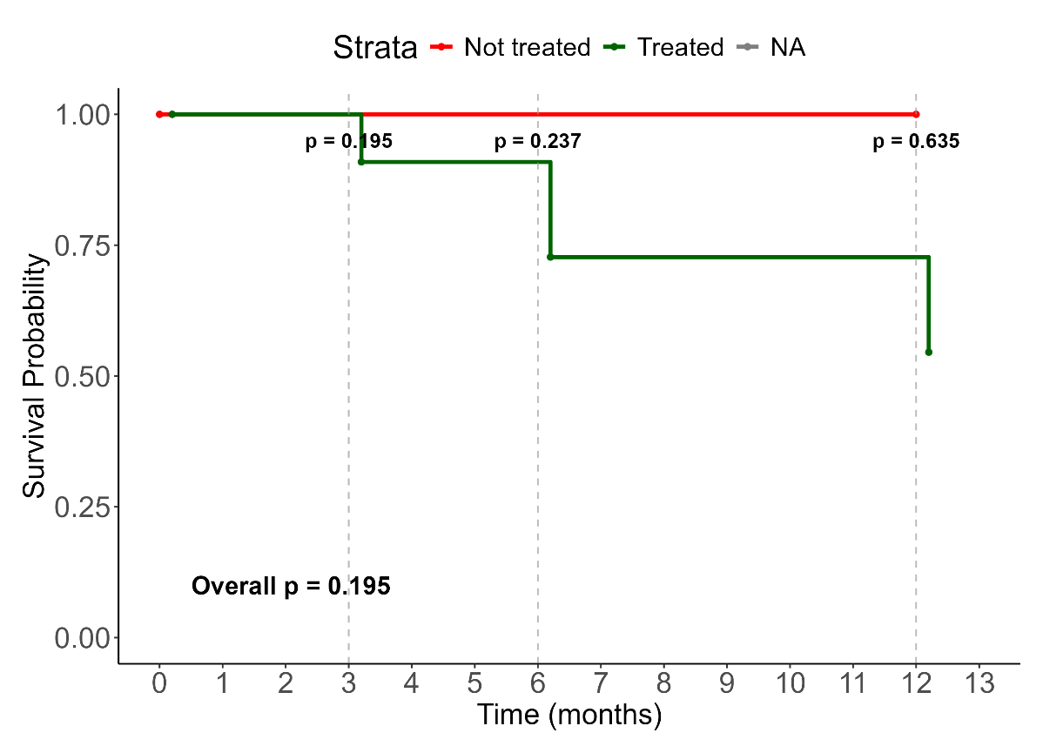
Figure 3: Kaplan meier for treated vs untreated n=14

The Kaplan-Meier analyses showed survival benefit in patients with AI compared to those without AI at 12 months of followup. There was also no survival benefit for the AI patients who received glucocorticoid replacement versus those who did not.
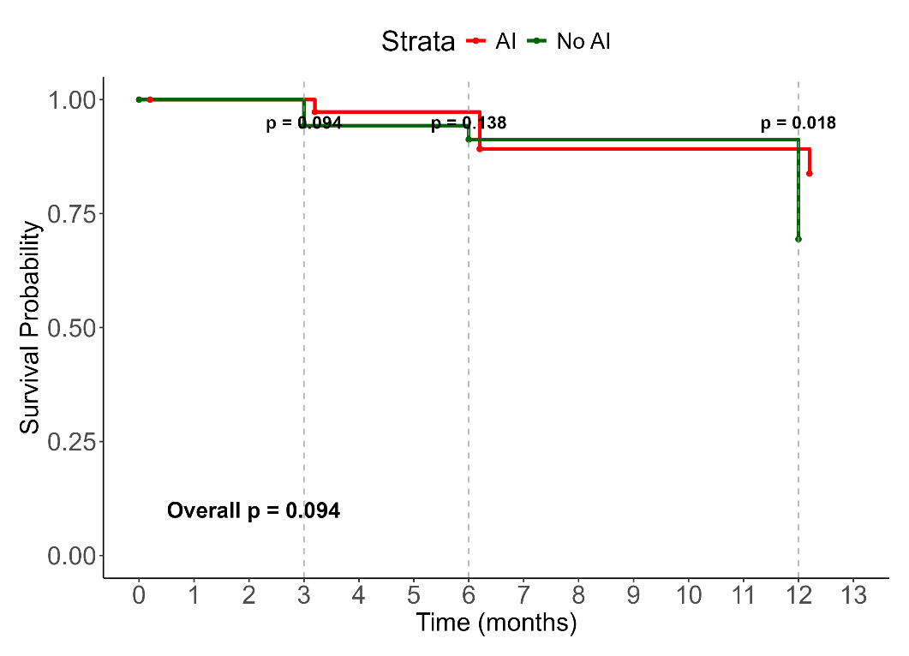
Fig 2: Mortality evaluation of patients with AI vs those without for the 37 (14 stimulated and 23 non-stimulated)

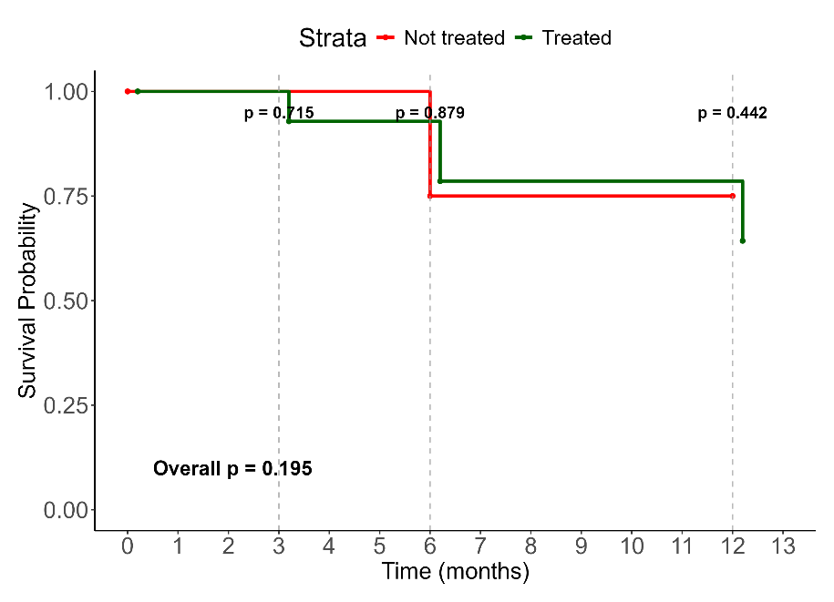
Fig 3: Mortality evaluation of treated vs Untreated AI patients for the 37 (14 stimulated and 23 non-stimulated)

?? Analysis of patients who failed synacthen test (163 -14 = 149) and (21) random cortisol < 274, discuss the results separately

Predictors of mortality:
Accelerated mortality was associated with increased skin pigmentation, poor appetite, raised random serum cortisol and plasma ACTH. Patients with a self-reported increase in skin pigmentation had a 51% increase in the odds of death [OR = 1.51 (95%CI: 1.03, 2.22)]; p=0.033, but this was not exclusively due to primary hypoadrenalism. Poor appetite was associated with a 77% likelihood of premature death [OR=1.77 (95%CI: 1.11, 2.90)]; p=0.020. Opiate use was associated with a 44.5% reduction in the odds of mortality [aOR = 0.555 (95%CI:0.33, 0.87)]; p=0.013. For every 50 nmol/L increase in the random serum cortisol, there was an associated 14% increase in the likelihood of death within 12 months [OR = 1.14, (95% CI:1.08, 1.21)]; p<0.001. For every 100 pg/L increase in the plasma ACTH, there was a 117% increase in odds of death [OR = 2.17, (95%CI:1.35, 3.72)]; p<0.026.
After adjusting for several factors, as shown in Table 4, a decrease in systolic, but increased diastolic blood pressures, increased random cortisol and opiate use were independently associated with premature mortality. A 10 mmHg increase in diastolic blood pressure was associated with a 3% increase in likelihood of premature mortality [aOR = 1.03 (95%CI: 1.00, 1.05)]; p=0.030). Every 10 mmHg increase in systolic blood pressure was associated with 2% reduction in the odds of mortality [aOR = 0.98 (95%CI: 0.96, 1.00)]; p=0.013. Every 50 nmol/L increase in random serum cortisol was associated with a 18% likelihood of premature death [aOR = 1.18 (95%CI: 1.10, 1.26)]; p<0.001. Opiate use was associated with 66% protection against death [aOR = 0.44 (95%CI: 0.23, 0.81); p=0.009.

Table 5: Multivariate mortality table
Table 4: Bivariate and Multivariate analysis of factors associated with time to mortality of patients in the entire cohort.

Characteristic | Bivariate |  |  |  | Multivariable (Pooled)
 | N | OR¹ | 95% CI² | p-value | Adj. OR³ | 95% CI² | p-value
History
Increased skin pigmentation | 525 | 1.51 | 1.03, 2.22 | 0.033 | 1.36 | 0.87, 2.14 | 0.176
Poor appetite | 535 | 1.77 | 1.11, 2.90 | 0.020 | 1.18 | 0.68, 2.06 | 0.550
Liking for salt | 536 | 1.33 | 0.92, 1.95 | 0.133
Nausea | 538 | 1.40 | 0.96, 2.05 | 0.080
Systolic Blood Pressure | 553 | 0.93 | 0.84, 1.03 | 0.181
Diastolic Blood Pressure | 553 | 1.13 | 0.98, 1.30 | 0.088
Investigations
Haemoglobin (Drop) | 558 | 0.92 | 0.85, 1.00 | 0.060
Clostridium difficile | 549 | 0.49 | 0.14, 1.32 | 0.196
Increased Random cortisol | 548 | 1.14 | 1.08, 1.21 | <0.001 | 1.15 | 1.08, 1.22 | <0.001
Basal_cortisol | 167 | 1.06 | 0.98, 1.15 | 0.134
Increased ACTH | 548 | 2.17 | 1.35, 3.72 | 0.003 | 1.55 | 0.90, 2.67 | 0.112
Cryptococcus neoformans | 549 | 1.72 | 0.79, 3.67 | 0.161 | 1.58 | 0.63, 3.97 | 0.331
Pneumonia | 549 | 0.66 | 0.34, 1.21 | 0.196 | 0.59 | 0.26, 1.32 | 0.196
CD4 count | 557 | 0.77 | 0.56, 1.06 | 0.113
Viral load | 126 | 1.08 | 0.98, 1.21 | 0.142
Medications
Opiate use | 563 | 0.55 | 0.33, 0.87 | 0.013 | 0.54 | 0.32, 0.89 | 0.016
Fluconazole | 563 | 1.64 | 0.98, 2.71 | 0.056 | 1.68 | 0.96, 2.94 | 0.070
Addissons disease | 563 | 1.33 | 0.40, 3.90 | 0.651 | 2.15 | 0.60, 7.69 | 0.239
¹Odds Ratio; ²95% Confidence interval; ³Adjusted Odds Ratio, ACTH Adrenocorticotrophin hormone, Hb haemoglobin, VL Viral load.

N=37

 | Bivariate |  |  |  |  | Multivariable (Pooled)
Characteristic | N | OR | 95% CI | 95% CI | B-H Adj. p-value¹ | Adj. OR (95% CI) | 95% CI | p-value
History
Increased skin pigmentation | 525 | 1.51 | 1.03, 2.22 | 1.03, 2.22 | 0.127 | 1.19 | 0.73, 1.92 | 0.488
Poor appetite | 535 | 1.77 | 1.11, 2.90 | 1.11, 2.90 | 0.094
Liking for salt | 536 | 1.33 | 0.92, 1.95 | 0.92, 1.95 | 0.192
Nausea | 538 | 1.40 | 0.96, 2.05 | 0.96, 2.05 | 0.167
Systolic Blood Pressure | 553 | 0.93 | 0.84, 1.03 | 0.84, 1.03 | 0.207 | 0.98 | 0.96, 1.00 | 0.013
Diastolic Blood Pressure | 553 | 1.13 | 0.98, 1.30 | 0.98, 1.30 | 0.167 | 1.03 | 1.00, 1.05 | 0.030
Investigations
Haemoglobin (Drop) | 558 | 0.92 | 0.85, 1.00 | 0.85, 1.00 | 0.162
Clostridium difficile | 549 | 0.49 | 0.14, 1.32 | 0.14, 1.32 | 0.207
Increased Random cortisol | 548 | 1.14 | 1.08, 1.21 | 1.08, 1.21 | <0.001 | 1.18 | 1.10, 1.26 | <0.001
Basal_cortisol | 167 | 1.06 | 0.98, 1.15 | 0.98, 1.15 | 0.192
Increased ACTH | 548 | 2.17 | 1.35, 3.72 | 1.35, 3.72 | 0.026 | 1.13 | 0.58, 2.18 | 0.720
Cryptococcus neoformans | 549 | 1.72 | 0.79, 3.67 | 0.79, 3.67 | 0.204 | 1.98 | 0.62, 6.28 | 0.247
Pneumonia | 549 | 0.66 | 0.34, 1.21 | 0.34, 1.21 | 0.207
CD4 count | 557 | 0.77 | 0.56, 1.06 | 0.56, 1.06 | 0.192
Viral load | 126 | 1.08 | 0.98, 1.21 | 0.98, 1.21 | 0.192
Medications
Opiate use | 563 | 0.55 | 0.33, 0.87 | 0.33, 0.87 | 0.080 | 0.44 | 0.23, 0.81 | 0.009
Fluconazole | 563 | 1.64 | 0.98, 2.71 | 0.98, 2.71 | 0.162 | 1.61 | 0.83, 3.10 | 0.158
¹False discovery rate correction for multiple testing
Abbreviations: CI = Confidence Interval, OR = Odds Ratio

Discussion:

In our study of HIV positive patients with advanced disease characterized by a CD4 count less than 100 cells/mm³ and an OI, the prevalence of adrenal insufficiency was 6.22%. In the entire cohort of patients, the group with the lowest CD4 counts were younger than in the remaining CD4 tertiles. Cryptococcal infection occurred more often among patients who were HAART naïve, compared with those on HAART. Patients with adrenal insufficiency had a comparatively higher incidence of cryptococcal infection. SAI, compared to PAI predominated in approximately 4:1 ratio. Cryptococcal neoformans infection, lower random, basal, stimulated and incremental cortisol concentrations were associated with higher mortality in the AI group. Increased skin pigmentation, poor appetite, raised cortisol and ACTH concentrations were associated with increased mortality at 12 months after admission to hospital. The twelve-month mortality for the AI group was 35.7%, and only in the stimulated group. Independent factors predictive for mortality in this cohort were a decrease in systolic and an increase in diastolic blood pressure, and elevated random cortisol. There was was better survival between patients with AI compared to those without AI at 12 months followup, and none between AI patients who were treated steroids and patients with AI who were not..

HIV impedes normal immunity by directly infecting and eliminating CD4 cells in inadequately-treated patients [22] (22). Patients with a CD4 count less than 100 cells/mm³ represent profoundly immunosuppression predisposed to life-threatening (OI’s) and malignancies and require HAART to favourably alter their prognoses (Michael Carter). Although we found a prevalence of AI in our cohort of 6.22%, using the 250 µg tetracosactide test together with a stimulated cortisol cutoff of 400 nmol/L and a random cortisol of less than 274 nmol/L in patients who declined the stimulation test. When using the stimulated cut-off points of 400 nmol/L, the reported incidence was 2.49%. { We used the new Elecsus II assay cutt-off level of 400 nmol/L as suggested by Javorsky et al to improve the diagnostic accuracy of adrenal insufficiency Javorsky, 2021 #247}. We also used the additional criteria of random cortisol of 274 nmol/L for patients who did not consent to the stimulation test. There was no mortality in this group even though the clinical characteristics were not significantly different from stimulated AI group in which there was significant mortality. Various reported prevalences of AI exist in patients with HIV ranging from 5.4% in a USA study by Membreno et al, using a 250µg tetracosactide stimulated cortisol cutoff of 687 nmol/L [23] Others have found a prevalence of 19.2% in a small study of 26 patients in India [24], 24% [25] and 33.3% in Nigeria, using the 1 µg stimulation with a 504 nmol/L cortisol cutoff [26]. Various prevalences of AI among HIV-positive patients are attributable to bias arising from small study sizes and non-standardised cut-offs for cortisol. We cannot advocate for routine exclusion of AI among HIV-positive patients, despite prior recommendations [24]. Screening for AI in advanced HIV should be reserved for very high-risk cases, especially if there is Cryptococcus neoformans co-infection.

Patients in the lowest CD4 tertile, were younger, reflecting that they may be less predisposed to being tested for HIV or exhibit a delay in initiation of antiretroviral therapy [27]. Younger patients may underestimate their risk of testing positive due to perceived good health [28]. They may also fear positive results and the mandatory incumbent-associated lifestyle changes necessary with a positive result, stigma and discrimination within communities, and concerns about the maintenance of confidentiality of their HIV results [29]. Very low CD4 counts if using antiretroviral therapy may be due to antiretroviral resistance, HIV mutations, poor compliance or simultaneous multiple HIV strain coinfection (superinfection), thought to be rare among younger individuals [30]. As expected, the subgroup with the lowest CD4 counts also had the highest viral loads and associated leukopaenia, lymphopaenia, neutropaenia relative to the groups with higher CD4 counts.

AI in our cohort was associated with a higher incidence of cryptoccocal infections. Disseminated cryptococcal infection may induce PAI, through direct infiltration of the adrenal glands [33] and its incumbent therapy, fluconazole may result in AI through inhibiting steroidogenesis [34] [35]. SAI appears to occur more commonly than PAI among patients with advanced HIV, possibly due to elevated concentrations of proinflammatory circulating cytokines. Proinflammatory cytokines have the potential to directly suppress CRH and ACTH, which may be reversible. [41]. The majority (%) of the AI patients received steroid therapy. It was the attending doctor’s decision whether or not to initiate the steroid treatment based on the results. The treatment appears to offer no significant mortality benefit to treated AI patients versus those who did not reveive treatment.

The association between Cryptococcus neoformans and mortality in HIV is well described, with Rajasingham et al, reporting that 75% of the cryptococcal meningitis deaths occur in sub-Saharan Africa [42], We have observed an association of cryptococcal infection and mortality in patients with AI. Despite initiating hydrocortisone replacement therapy, mortality was higher than the background of HIV positive patients suggesting that they may have died from an adrenal crisis, or that the combination of AI, HIV and cryptococcus represented overwhelming insults [43]. Chronic stress and elevated cortisol have been associated with increased intensive care unit (ICU) mortality [44, 45]. The association of mortality and lower random, basal, stimulated and incremental cortisol [46] concentrations in AI, representing a U-shaped relationship in respect of cortisol and mortality. (Marklund N et al)

The strength of the study lies in its large size, a systematic approach to evaluating all patients for AI and follow-up to determine survival. As with all large studies there were missing data. For example, it could be considered a detraction that all patients with a random cortisol concentration less than 400 nmol/L did not undergo a tetracosactide test. It should also be recognised that our findings are not transferable to HIV positive patients with higher CD4 counts and absence of OI. This may represent a limitation of the assay, with a tendency to over-diagnose cases.

Conclusion
This large, advanced HIV study revealed a significant risk of AI varying between 2% and 4%, depending on the chosen stimulated cortisol cut off points, and validated diagnostic criteria. Cryptococcal infection was associated with an increased risk of AI and mortality. The unexpected finding of survival benefit for AI patients at 12 months followup compared to those without should be viewed with caution, especially in light of the finding that steroid treatment of AI group did was not associated with survival benefit within this group. We believe that early detection of AI, coupled with early treatment, better disease literacy and frequent follow-up may explain this paradoxical survival benefit.

References

1. Dunlop, D., Eight-six cases of Addison's disease. British medical journal, 1963. 2(5362): p. 887.
2. Betterle, C. and L. Morlin, Autoimmune Addison’s disease, in Pediatric Adrenal Diseases. 2011, Karger Publishers. p. 161–172.
3. Ross, I.L. and N.S. Levitt, Addison's disease symptoms--a cross sectional study in urban South Africa. PLoS One, 2013. 8(1): p. e53526.
4. Mofokeng, T.R., et al., Significant barriers to diagnosis and management of adrenal insufficiency in Africa. Endocrine connections, 2020. 9(5): p. 445–456.
5. Mofokeng, T.R.P., et al., Tiered healthcare in South Africa exposes deficiencies in management and more patients with infectious etiology of primary adrenal insufficiency. PLoS One, 2020. 15(11): p. e0241845.
6. Goliber, T., The status of the HIV/AIDS epidemic in Sub-Saharan Africa. Population Reference Bureau, 2002.
7. Hofbauer, L.C. and A.E. Heufelder, Endocrine implications of human immunodeficiency virus infection. Medicine, 1996. 75(5): p. 262–278.
8. Boulle, A., et al., Mortality in patients with HIV-1 infection starting antiretroviral therapy in South Africa, Europe, or North America: a collaborative analysis of prospective studies. PLoS medicine, 2014. 11(9): p. e1001718.
9. Arlt, W., Adrenal insufficiency. Clinical medicine, 2008. 8(2): p. 211.
10. Husebye, E.S., et al., Adrenal insufficiency. The Lancet, 2021. 397(10274): p. 613–629.
11. Eledrisi, M.S. and A.C. Verghese, Adrenal insufficiency in HIV infection: a review and recommendations. The American journal of the medical sciences, 2001. 321(2): p. 137–144.
12. Bornstein, S.R., Predisposing factors for adrenal insufficiency. New England Journal of Medicine, 2009. 360(22): p. 2328–2339.
13. Afreen, B., K.A. Khan, and A. Riaz, Adrenal insufficiency in Pakistani HIV infected patients. Journal of Ayub Medical College Abbottabad, 2017. 29(3): p. 428–431.
14. Odeniyi, I., et al., Adrenocortical function in Nigerians with human immunodeficiency virus infection. Ghana Medical Journal, 2013. 47(4): p. 171.
15. Sharma, N., et al., Presence, patterns & predictors of hypocortisolism in patients with HIV infection in India. Indian Journal of Medical Research, 2018. 147(2): p. 142–150.
16. Bergthorsdottir, R., et al., Premature mortality in patients with Addison’s disease: a population-based study. The Journal of Clinical Endocrinology & Metabolism, 2006. 91(12): p. 4849–4853.
17. Johannsson, G., et al., Adrenal insufficiency: review of clinical outcomes with current glucocorticoid replacement therapy. Clinical endocrinology, 2015. 82(1): p. 2–11.
18. Tchouakak, A., HIV progress raises life expectancy in Africa–UN. SciDev. net-Health, 2024.
19. Druce, I., et al., Routine screening for central and primary adrenal insufficiency during immune-checkpoint inhibitor therapy: an endocrinology perspective for oncologists. Current Oncology, 2022. 29(7): p. 4665–4677.
20. Holst, J.P., et al., Use of steroid profiles in determining the cause of adrenal insufficiency. Steroids, 2007. 72(1): p. 71–84.
21. Vogeser, M., et al., Multicenter performance evaluation of a second generation cortisol assay. Clinical Chemistry and Laboratory Medicine (CCLM), 2017. 55(6): p. 826–835.
22. Février, M., K. Dorgham, and A. Rebollo, CD4+ T cell depletion in human immunodeficiency virus (HIV) infection: role of apoptosis. Viruses, 2011. 3(5): p. 586.
23. Membreno, L., et al., Adrenocortical function in acquired immunodeficiency syndrome. The Journal of Clinical Endocrinology & Metabolism, 1987. 65(3): p. 482–487.
24. Prasanthai, V., et al., Prevalence of adrenal insufficiency in critically ill patients with AIDS. JOURNAL-MEDICAL ASSOCIATION OF THAILAND, 2007. 90(9): p. 1768.
25. Bhatia, E., Adrenal disorders in people with HIV: The highs and lows. Indian Journal of Medical Research, 2018. 147(2): p. 125–127.
26. Hassan, A., et al., Prevalence of Adrenocortical Insufficiency in Treatment-Naïve HIV Patients in Maiduguri: A Cross-Sectional Study. Sch J Med Case Rep, 2025. 8: p. 1914–1919.
27. Ahmed, S.I., et al., Attitudes and barriers towards HIV screening: A qualitative study of people living with HIV/AIDS (PLWHA) in Malaysia. Journal of Infection Prevention, 2017. 18(5): p. 242–247.
28. Peralta, L., et al., Barriers and facilitators to adolescent HIV testing. AIDS patient care and STDs, 2007. 21(6): p. 400–408.
29. Katirayi, L., et al., Understanding gender differences of people with HIV newly diagnosed or returning to care with advanced HIV disease in Malawi: a qualitative study. BMC Public Health, 2023. 23.
30. Redd, A.D., et al., The rates of HIV superinfection and primary HIV incidence in a general population in Rakai, Uganda. The Journal of infectious diseases, 2012. 206(2): p. 267–274.
31. Zaloga, G.P. and P. Marik, Hypothalamic-pituitary-adrenal insufficiency. Critical care clinics, 2001. 17(1): p. 25–41.
32. Elansary, E. and J. Earis, Rifampicin and adrenal crisis. British Medical Journal (Clinical research ed.), 1983. 286(6381): p. 1861.
33. Ito, M., et al., Disseminated cryptococcosis with adrenal insufficiency and meningitis in an immunocompetent individual. Internal Medicine, 2017. 56(10): p. 1259–1264.
34. Paolo Jr, W.F. and J.D. Nosanchuk, Adrenal infections. International journal of infectious diseases, 2006. 10(5): p. 343–353.
35. Pont, A., et al., Ketoconazole blocks adrenal steroid synthesis. Annals of internal medicine, 1982. 97(3): p. 370–372.
36. Oelkers, W., Adrenal insufficiency. N Engl J Med, 1996. 335(16): p. 1206–12.
37. Alexandraki, K.I. and A. Grossman, Diagnosis and management of adrenal insufficiency. Endotext [Internet], 2018.
38. Rushworth, R.L. and D.J. Torpy, A descriptive study of adrenal crises in adults with adrenal insufficiency: increased risk with age and in those with bacterial infections. BMC endocrine disorders, 2014. 14(1): p. 79.
39. Lousada, L.M., B.B. Mendonca, and T.A. Bachega, Adrenal crisis and mortality rate in adrenal insufficiency and congenital adrenal hyperplasia. Archives of Endocrinology and Metabolism, 2021. 65(4): p. 488–494.
40. Hariram, T., K. Naidoo, and S. Ramji, Hypernatraemic dehydration in infants with acute gastroenteritis at King Edward VIII Hospital, Durban, South Africa. South African Journal of Child Health, 2018. 12(1): p. 10–14.
41. Donegan, D. and I. Bancos. Opioid-induced adrenal insufficiency. in Mayo Clinic Proceedings. 2018. Elsevier.
42. Rajasingham, R., et al., Global burden of disease of HIV-associated cryptococcal meningitis: an updated analysis. The Lancet infectious diseases, 2017. 17(8): p. 873–881.
43. Chaka, W., et al., Presentation and outcome of suspected sepsis in a high-HIV burden, high antiretroviral coverage setting. International Journal of Infectious Diseases, 2020. 96: p. 276–283.
44. Van den Berghe, G., Adrenal function/dysfunction in critically ill patients: a concise narrative review of recent novel insights. Journal of anesthesia, 2021. 35(6): p. 903–910.
45. Christ-Crain, M., et al., Free and total cortisol levels as predictors of severity and outcome in community-acquired pneumonia. American journal of respiratory and critical care medicine, 2007. 176(9): p. 913–920.
46. Maqbool, M., et al., Prevalence of occult adrenal insufficiency and the prognostic value of a short corticotropin stimulation test in patients with septic shock. Indian Journal of Critical Care Medicine: Peer-reviewed, Official Publication of Indian Society of Critical Care Medicine, 2009. 13(2): p. 85.
47. Ngaosuwan, K., et al., Increased mortality risk in patients with primary and secondary adrenal insufficiency. The Journal of Clinical Endocrinology & Metabolism, 2021. 106(7): p. e2759–e2768.

